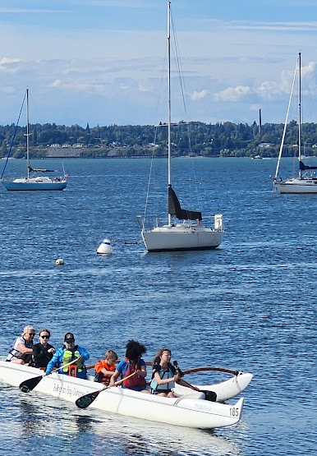
Summer Youth Internship Program for Ages 15-18

Our programs blend Polynesian cultural traditions, environmental awareness, and water safety—while having fun learning to paddle a six-person outrigger canoe. Youth Interns work alongside Program Staff to support activities and paddling practice for keiki (ages 8-14). No prior paddling experience is required—just a willingness to learn, and have fun! This is your chance to become a role model, grow as a leader, and be a part of an exciting and supportive paddling community.
Paddle with Bellingham Bay Outrigger Paddlers!

Why Apply?
- Leadership & Mentorship – Learn from passionate adult paddlers and coaches.
- Skill Development – Enhance teamwork, communication, and coaching abilities.
- Community Connection – Be a valued part of the BBOP ohana (family).
- Exclusive Benefits – Receive a BBOP T-shirt, a free paddling membership (youth, competitive, or recreational), and the opportunity for a letter of recommendation.

When & Where?
📅 Program Schedule: Interns are asked to commit to at least one full session (8 practices over
the 4 weeks): Session 1: May 5 - June 4
Session 2: June 9 - June 29 & 30
Session 3: July 21 - Aug 13
🕓 Practice Times: Tuesdays & Thursdays, 4:15 – 5:30 PM
📍 Location: Community Boating Center, 555 Harris Ave., Bellingham, WA

Apply Today!
Don’t miss this opportunity to grow as a leader, inspire younger paddlers, and be part of a unique paddling tradition. Space is limited—secure your spot and start paddling in March!
- Submit a completed internship application (click here or scan the QR code).
- Deadlines: Apply ASAP so there is time to learn to paddle before the next session starts!

